Mausham Bista

Health:
Health is not only about physical, but it must include mental and spiritual health also. If we balance these our health will be better. Moreover, I think being healthy is the most important than other thing in our life. For examples: If you are the richest person and have throat soar. You are sitting in the couch seeing the best view and trying to eat fruits but when you eat every time your throat pain which will disturb you. So, peace of mind, physical body and spiritual body should be good for our life to be good. This involves regularly exercising, eating healthfully, and meditating each day.

Work:
Work is something that we need to do be financially independent. I have worked as freelance web developer. It was quite fun and lots of hard work as beginner. I have also worked as Pathao Rider (Uber Nepal). I have done some other unpaid work also such as volunteering. All the work required our time and effort.

Play:
I have been to eSport for long time. ESport was my passion; it was fun, entertaining and
Full of money with very high competition. I also like to play cricket a lot.

Love:
Love is feeling we have for other when we start to like. So, the love in my life is my family, girlfriend, and friends. They are the person who are very close to me and always motivate me. Moreover, Jesus Christ is also love of my life.

Workview Reflection:
I work both because I need to support myself financially and because I need to keep myself occupied. Work is an opportunity to follow a passion and discover fresh approaches to use my skills to make the world a better place. Working on something that makes me happy and fulfilled is what constitutes good, useful employment. Just getting things done won't do for me; they must be flawless. I must have at least learnt something, and it must have been done carefully. I can gain experience in the industry I want to work in by being allowed to work. I need to seize every chance that presents itself if I want to go where I'm going.

Lifeview Reflection:
Giving for self-gratification is totally OK since we all want to feel good about ourselves, but it would be evil to be able to assist and have the resources to help but still decide not to. That's the same as killing someone in my opinion. Nobody should believe that they are helpless. The same chances as the next person are everyone's right. Because each individual has a lesson to impart on us so that we may impart it to others, we encounter people in our lives. We learn since there is no other way to develop. We feel delight because we grow through pain. Because we gain knowledge from the suffering of injustice, we experience justice. Because we take lessons from the past, we strive for love and peace in our lives. Every second of life teaches us something. Love improves everyone's quality of life and turns the world around.

My life and work both show a desire to support another person's sense of fulfillment. My workview is driven by the desire for stability and control over my own life, and my Lifeview is motivated by the knowledge around myself. However, it is clear that my Workview is influenced by my Lifeview. My desire to contribute to the community keeps me committed to the job path I’ve chosen.

Good time Journal Entries:
I played PUBG and FIFA game with friends where we all were very much excited with lots of fun. It gave all of very good break from all the busy life and positive energy. I did laundry last week which was positive thing for me because I had not done it for a month. Lots of assignment, projects and other things had really made my mind crazy so, I went to park this week to relax my mind and to feel the nature and the environment, after that I received lots of energy that made my mind really peace. I ate Subway this week which wasted my money and was unsignificant for me. I also went to my on-campus job this week which kept me busy, I used lots of heavy equipment and other stuff at work. I watched TV whole day this week which really took my whole day time, and I was not able to do anything productive that day which was bad and unsignificant thing I did. I also went to Idaho Falls this week for my social security number which was good thing I did this week. I also went to maize with my FHE group and had fun but then realized that I had assignment due, and I missed which almost led my grades from A to B so, that was negative thing happened to me. I finished all my project which gave me positive energy to do my other things. I also made my bed and cleaned my room which really gave me positive vibe and more engagement with myself. These all things I do are familiar to me, and they sometime give me positive vibe and more engagement and other gives me negative energy with few engagements.

3 Mind Maps:
I think for me playing games and doing assignment really keeps me engaged, I do these things with very good flow and have a lot of energy for this. Whenever I play game, I am 100% focused to that and I need to engage more to play well with that game. When I play with my friends we go with flow and start to play for long time like we play for whole day. I know it consumes time and lots of people might think that it is very bad but for me it really gives me positive energy to do other work also as it gives me positive energy after I do good with game for which I need to be more engaged and flow with game. Similarly, it is same when I start to do assignments. As I am computer science student it needs to be more engaged with that and more effort and energy is needed to complete it. When I start to do if I stop at the mid then I again need to be more focused and more energy is required so, for this I need to go with flow without any interruption to be more effective while doing homework. Whereas going to park is something that gives me very much energy. It makes my mind cool and get me engaged with the environment and showers me with all the positive energy.

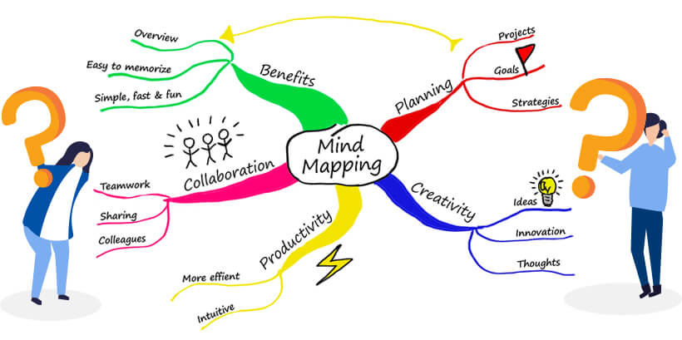

Odyssey Plan

